Installing the Productivity Ribbon

Caution about custom ribbons
Note: If you have created any custom ribbons in your Word application, this process will remove them. If you wish to keep your other custom ribbons, you must either recreate them after installing the productivity ribbon or export them and merge your custom ribbon definitions with the productivity ribbon install file before installing. (This process is beyond the scope of these instructions.)

Installation instructions
Here are some quick install instructions for the productivity ribbon.
- Save the productivity ribbon install file on your local drive. The file name of the ribbon install file is: Word2010ProductivityRibbon.exportedUI
- Start Word 2010.
- Open the File menu (in upper left corner of Word window).
- Select Options menu. (This will open a Word Options dialog.)
- Select Customize Ribbon in the left sidebar of the Word Options dialog. (This will display the Customize Ribbon options.)
- Open the Import/Export dropdown menu (lower right corner of dialog).
- Select Import Customization File from the dropdown menu. (This will open a "File Open" dialog.)
- Select the productivity ribbon install file (saved above in step 1) and select the Open button.
  - A warning dialog will appear asking if you wish to replace all existing Ribbon and Quick Access Toolbar customizations for this program. Select Yes. (Note that if you have created other custom ribbons, they will be deleted.)
- In the Main Tabs section of the Customize Ribbon options, verify the Productivity (Custom) checkbox has been added. Be sure the checkbox is checked, or the productivity ribbon tab will not be visible in your Word application.
- Select the OK button to close the Word Options dialog. This completes the installation.

Screenshot before installing the ribbon
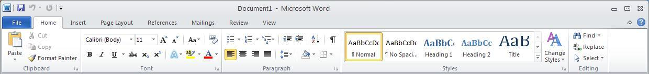
Before installing the productivity ribbon, the default ribbon tabs in Word 2010include, from left to right: Home, Insert, Page Layout, References, Mailings, Review, and View.

Screenshot of Productivity ribbon
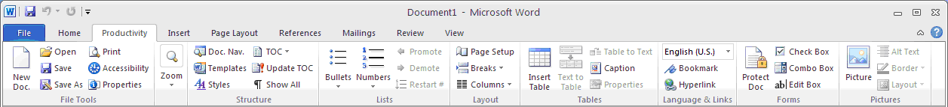
After installing, the Productivity Ribbon tab appears between the Home and Insert tabs. There are sections for File Tools, Zoom, Structure, Lists, Layout, Tables, Language & Links, Forms, and Pictures. Details of the tools found in each of these sections are provided below.
Note that the layout of tools in the ribbon may look slightly different, depending on your screen size and resolution.

